DAY-3 HTML5_Hands_On_ARSHIYA_ANJUM

Problem 1
Assessment Goal: Check ability to apply styling and understand selectors and box model.
Hands-on Tasks:
- Create an external CSS file and link it to HTML
- Apply different text styles to headings and paragraphs
- Add background color and borders to a section
- Demonstrate margin and padding on a div
- Style the form created on Day 2
Expected Outcome:
A visually styled webpage using external CSS and proper selectors.
CODE:
Index.html:

<!-- Arshiya_Anjum_HTML&CSS_Day3_Handson_problem_Statement1-->
<!DOCTYPE html>
<html lang="en">

<head>
<meta charset="UTF-8">
<title>Home</title>
<link rel="stylesheet" href="style.css">
</head>

<body>

<nav>
<a href="index.html">Home</a> |
<a href="contact.html">Contact</a>
</nav>

<h1>Welcome to Our Website</h1>
<p>Register to access our services, manage your account, and stay updated with the latest features and announcements.
Please fill in your personal details accurately</p>

<!-- Section with background and border -->
<section class="form-section">
<form>
<label>Name:</label><br>
<input type="text" placeholder="Enter your name" required><br><br>

<label>Email:</label><br>
<input type="email" placeholder="Enter your email" required><br><br>

<label>Password:</label><br>
<input type="password" placeholder="Enter password" required><br><br>

<input list="courses" placeholder="Choose or type course" required>

<datalist id="courses">
<option value="HTML">
<option value="CSS">
<option value="JavaScript">
<option value="Python">
</datalist>
<br><br>

<button type="submit">Register</button>
</form>
</section>

<!-- Box model demonstration -->
<div class="box">
You are close to register
</div>

</body>
</html>

Contact.html:

<!DOCTYPE html>
<html lang="en">
<head>
<meta charset="UTF-8">
<title>Contact</title>
<link rel="stylesheet" href="style.css">

</head>

<body>

<nav>
<a href="index.html">Home</a> |
<a href="contact.html">Contact</a>
</nav>

<h1>Contact Us</h1>
<p>Email: Anjum@123.com</p>
<p>Phone: +91 98765 43210</p>

</body>
</html>

Style.css:

/ * Page styling */
body {
font-family: Arial, sans-serif;
background: linear-gradient(to right, #39a9db, #26c6da);
text-align: center;
}

/* Navigation */
nav {
background: #222;
padding: 10px;
}

nav a {
color: white;
text-decoration: none;
margin: 10px;
font-weight: bold;
}

/* Headings */
h1 {
color: white;
}
p{
color: #000;
background-color: #afbfcf;
font: 1em sans-serif;
}
/* Section with background and border */
.form-section {
background: #e6e6e6;
border: 2px solid #ccc;
width: 320px;
margin: 20px auto;
padding: 25px;
border-radius: 12px;
text-align: left;
}

/* Form inputs */
form input {
width: 100%;
padding: 8px;
border-radius: 5px;
border: 1px solid #ccc;
}

/* Button */
button {
width: 100%;
padding: 10px;
background: #4a90e2;
color: white;
border: none;
border-radius: 6px;
font-weight: bold;
}

button:hover {
background: #357abd;
}
/* Box model demonstration */
.box {
background: #fff3cd;
border: 2px;
margin: 40px; /* outer space */
padding: 40px; /* inner space */
font-weight: bold;
}

OUTPUT:

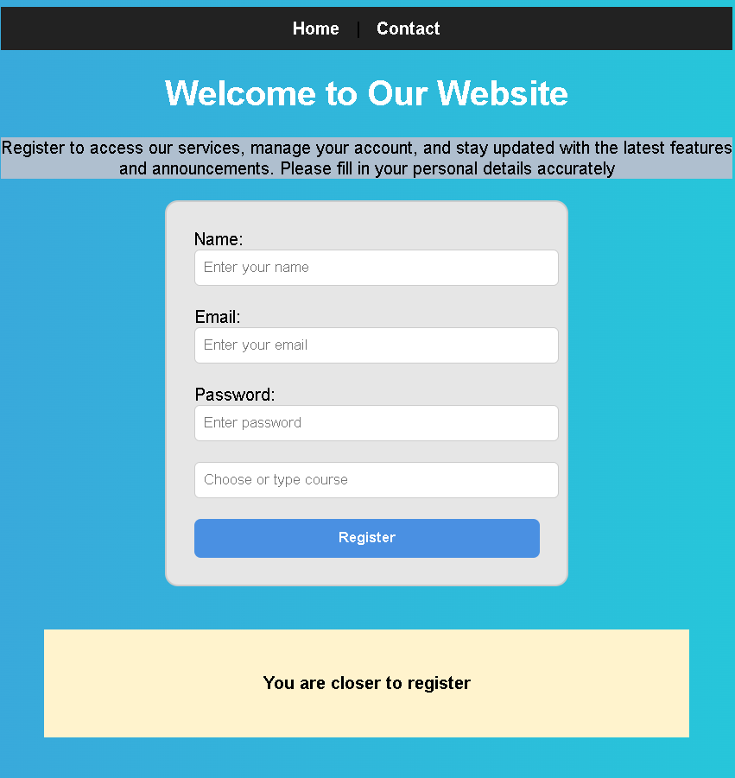

Code Explanation :
Both pages begin with <!DOCTYPE html>, which declares the document as HTML5.
• The <html> and <head> sections define the page structure, language, character encoding, and browser tab title.
• Internal CSS inside the <style> tag is used to apply a gradient background, fonts, and alignment for a clean layout.
• A navigation bar is created using the <nav> element, containing links to the Home and Contact pages.
• The Home page displays a welcome heading and includes a registration form for users.
• The form contains fields for name, email, password, gender (radio buttons), course selection using <datalist>, and a submit button.
• The Contact page shows a “Contact Us” heading along with email and phone details using paragraph tags.

Problem 2: Personal Profile Card (Level-1)
Scenario
You are building a simple personal profile card for a portfolio website.
The card will display a user’s name, role, short bio, and contact button, styled purely using CSS.
📌 Requirements
Create a profile card layout containing:
- Name (heading)
- Role/title
- Short description paragraph
- Contact button
Apply:
- Text formatting (alignment, decoration)
- Font styles (font-family, size, weight)
- Typography enhancements (line-height, letter-spacing)
Use the CSS Box Model:
- Padding for spacing inside the card
- Border to define the card boundary
- Margin to separate the card from the page edges
Add:
- Background color
- Border radius
- Hover effect on the button

🛠️ Technical Constraints
- Use only HTML + CSS
- No images or icons
- No frameworks (Bootstrap, Tailwind, etc.)
- Inline CSS not allowed (use <style> or external CSS)

🎯 Learning Outcome

You should be able to:
- Understand how CSS styles text and fonts
- Apply box model concepts effectively
- Style elements using colors, borders, and spacing
- Improve visual hierarchy using typography

CODE:

<!-- Arshiya_Anjum_HTML&CSS_Day3_Handson_problem_Statement2-->
<!DOCTYPE html>
<html lang="en">
<head>
<meta charset="UTF-8">
<title>Profile Card</title>

<style>

body {
font-family: Arial, sans-serif;
background: linear-gradient(to right, #97b6b4, #00f2fe);
display: flex;
justify-content: center;
align-items: center;
height: 100vh;
margin: 0;
}

.card {
background-color: white;
width: 300px;
padding: 20px;
border: 2px solid #ddd;
border-radius: 12px;
margin: 20px;
text-align: center;
box-shadow: 0 4px 10px rgba(0,0,0,0.1);
}

.card h1 {
font-size: 24px;
font-weight: bold;
margin-bottom: 5px;
letter-spacing: 1px;
}

.role {
color: #666;
font-size: 16px;
font-weight: bold;
margin-bottom: 15px;
text-decoration: underline;
}

.bio {
font-size: 14px;
line-height: 1.6;
margin-bottom: 20px;
}

.btn {
background-color: #4facfe;
color: white;
padding: 10px 18px;
border: none;
border-radius: 6px;
font-size: 14px;
font-weight: bold;
cursor: pointer;
text-decoration: none;
display: inline-block;
}

.btn:hover {
background-color: #007bff;
}
</style>
</head>

<body>

<div class="card">
<h1>Arshiya Anjum</h1>
<p class="role">Web Developer</p>
<p class="bio">
Passionate about creating simple, clean, and responsive websites using HTML and CSS.
</p>
<a href="#" class="btn">Contact Me</a>
</div>

</body>
</html>

OUTPUT:
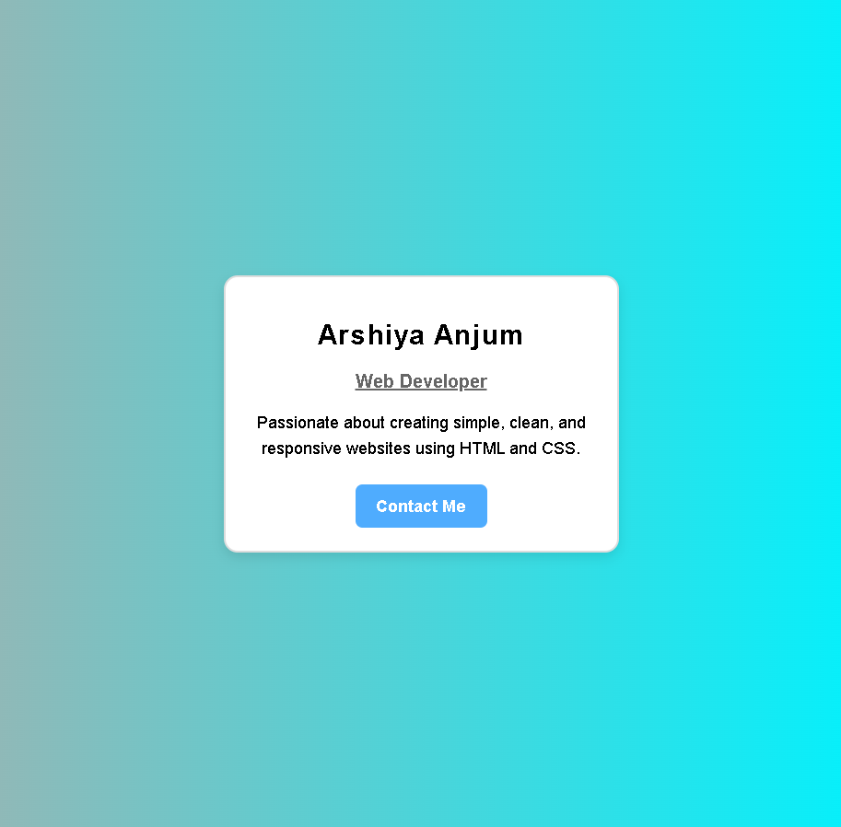

Code Explanation:
The profile card page is created using a single HTML file that displays personal details in a centered card layout.
• The page uses internal CSS to apply a gradient background and flexbox to center the card both vertically and horizontally.
• The card container has a white background, padding, rounded corners, border, and shadow to create a modern card appearance.
• The profile section includes the person’s name as a heading and the role displayed as a styled paragraph.
• A short bio paragraph describes the person’s skills and interests in web development.
• A “Contact Me” button is created using a styled anchor tag to look like a clickable button.
• Hover effects are applied to the button to improve user interaction and visual feedback.

Problem 3: Product Feature List Section (Level-1)
Scenario
You are designing a feature highlight section for a product landing page that lists key features in a visually appealing way.
📌 Requirements
Create a section with:
- Section heading
- List of 4–5 features
Style the list using:
- Custom fonts
- Text color and background color
- Border and padding for each feature item
Use:
- CSS selectors (element, class, descendant)
Apply hover effects on feature items

🛠️ Technical Constraints
- Use unordered list (<ul>)
- No JavaScript
- No layout frameworks
- Only basic HTML structure
🎯 Learning Outcome
You will be able to:
- Practice CSS selectors
- Style lists professionally
- Improve UI consistency

CODE:
<!-- Arshiya_Anjum_HTML&CSS_Day3_Handson_problem_Statement3-->
<!DOCTYPE html>
<html lang="en">
<head>
<meta charset="UTF-8">
<title>iPad Features</title>

<style>
/* Element selector */
body {
font-family: 'Segoe UI', sans-serif;
background-color: #f2f4f8;
margin: 0;
text-align: center;
}

/* Class selector */
.features {
background-color: white;
width: 380px;
margin: 50px auto;
padding: 25px;
border-radius: 12px;
box-shadow: 0 5px 12px rgba(0,0,0,0.1);
}

/* Descendant selector */
.features h2 {
color: #111;
letter-spacing: 1px;
margin-bottom: 20px;
}

/* List styling */
ul {
list-style: none;
padding: 0;
}

li {
background-color: #007aff;
color: white;
margin: 12px 0;
padding: 12px;
border-radius: 8px;
border: 2px solid #005ecb;
font-size: 15px;
transition: 0.3s;
}

/* Hover effect */
li:hover {
background-color: #005ecb;
transform: scale(1.04);
}
</style>
</head>

<body>

<section class="features">
<h2>iPad</h2>
<img src="ipad.jpg" alt="ipad">
<h3>Key Features</h3>

<ul>
<li>10.9-inch Liquid Retina Display</li>
<li>Powerful A14 Bionic Chip</li>
<li>All-day Battery Life</li>
<li>12MP Front and Rear Cameras</li>
<li>Apple Pencil & Magic Keyboard Support</li>
</ul>
</section>

</body>
</html>

OUTPUT:
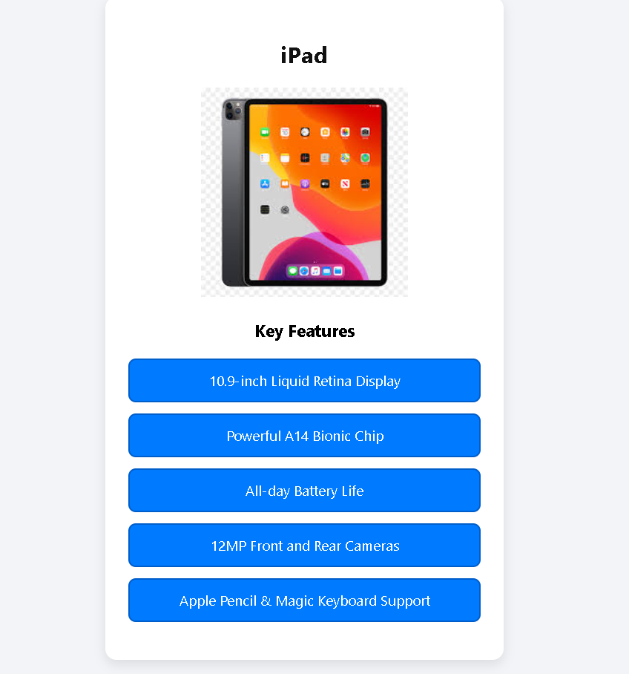

Code Explanation:
The page begins with <!DOCTYPE html>, which declares the document as HTML5.
• The <html> and <head> sections define the language, character encoding, page title, and internal CSS styling.
• The body element uses an element selector to apply a font, light background color, and centered text.
• The .features class creates a white card layout with padding, rounded corners, centered alignment, and a shadow effect.
• A descendant selector .features h2 styles the main heading with dark color and spacing.
• An image of the iPad is displayed using the <img> tag with an alternate text description.
• An unordered list <ul> shows the key features, and each <li> is styled with a blue background, white text, rounded corners, and a hover effect.

Problem 4: Responsive Blog Layout (Level-2)
Scenario
You are creating a blog homepage that displays articles in a modern responsive layout suitable for desktop, tablet, and mobile screens.
📌 Requirements
Create a page layout with:
- Header
- Main content area with multiple blog cards
Use:
- Flexbox or CSS Grid for layout
- Box model for spacing
Each blog card should contain:
- Title
- Short description
- Read More button
Apply:
- Background colors
- Borders
- Typography enhancements
Use media queries to:
- Display multiple columns on desktop
- Switch to single column on mobile
🛠️ Technical Constraints
- Only HTML + CSS
- No CSS frameworks
- No fixed widths (use percentages or flexible units)
🎯 Learning Outcome
Learners should be able to:
- Understand Flexbox/Grid layouts
- Apply responsive design principles
- Write effective media queries
- Build real-world page layouts

CODE:
<!-- Arshiya_Anjum_HTML&CSS_Day3_Handson_problem_Statement4-->
<!DOCTYPE html>
<html lang="en">
<head>
<meta charset="UTF-8">
<title>TechWorld Blog</title>

<style>
/* Reset */
* {
box-sizing: border-box;
margin: 0;
padding: 0;
font-family: 'Segoe UI', sans-serif;
}

body {
background-color: #77a4e8;
}

/* Header */
header {
background-color: #f0ebeb;
color: rgb(5, 1, 1);
padding: 15px 5%;
display: flex;
justify-content: space-between;
align-items: center;
}

header h1 {
font-size: 24px;
letter-spacing: 1px;
}

nav a {
color: rgb(15, 15, 15);
margin-left: 20px;
text-decoration: none;
font-weight: bold;
}

nav a:hover {
color: #00bfff;
}

/* Blog container */
.blog-container {
display: flex;
flex-wrap: wrap;
gap: 20px;
padding: 30px 5%;
}

/* Blog cards */
.card {
background: rgb(224, 228, 228);
padding: 20px;
border-radius: 10px;
border: 1px solid #ddd;
flex: 1 1 calc(33.33% - 20px);
box-shadow: 0 4px 8px rgba(0,0,0,0.08);
transition: 0.3s;
}

.card:hover {
transform: translateY(-5px);
}

.card h3 {
margin-bottom: 10px;
font-size: 20px;
color: #222;
}

.card p {
color: #555;
line-height: 1.6;
margin-bottom: 15px;
}

.btn {
background: #007bff;
color: white;
padding: 8px 14px;
text-decoration: none;
border-radius: 5px;
font-weight: bold;
}

.btn:hover {
background: #0056b3;
}

/* Tablet */
@media (max-width: 900px) {
.card {
flex: 1 1 calc(50% - 20px);
}
}

/* Mobile */
@media (max-width: 600px) {
header {
flex-direction: column;
gap: 10px;
text-align: center;
}

.card {
flex: 1 1 100%;
}
}
</style>
</head>

<body>

<header>
<h1>TechWorld</h1>
<nav>
<a href="#">Home</a>
<a href="#">Reviews</a>
<a href="#">Guides</a>
<a href="#">Contact</a>
</nav>
</header>

<main class="blog-container">

<div class="card">
<h3>Top Smartphones of 2026</h3>
<p>Discover the best smartphones with cutting-edge features, powerful processors, and stunning cameras.</p>
<a href="#" class="btn">Read More</a>
</div>

<div class="card">
<h3>Best Budget Laptops</h3>
<p>Looking for performance on a budget? Here are the best laptops under $800.</p>
<a href="#" class="btn">Read More</a>
</div>

<div class="card">
<h3>Wireless Earbuds Guide</h3>
<p>A complete guide to choosing the right Bluetooth earbuds for music, calls, and gaming.</p>
<a href="#" class="btn">Read More</a>
</div>

<div class="card">
<h3>How 5G is Changing the World</h3>
<p>Explore how 5G technology is transforming communication, gaming, and smart devices.</p>
<a href="#" class="btn">Read More</a>
</div>

<div class="card">
<h3>Smartwatch Buying Tips</h3>
<p>Learn what features to look for when buying a smartwatch in 2026.</p>
<a href="#" class="btn">Read More</a>
</div>

<div class="card">
<h3>Top Coding Apps for Beginners</h3>
<p>Start your programming journey with these beginner-friendly coding apps.</p>
<a href="#" class="btn">Read More</a>
</div>

</main>

</body>
</html>

OUTPUT:
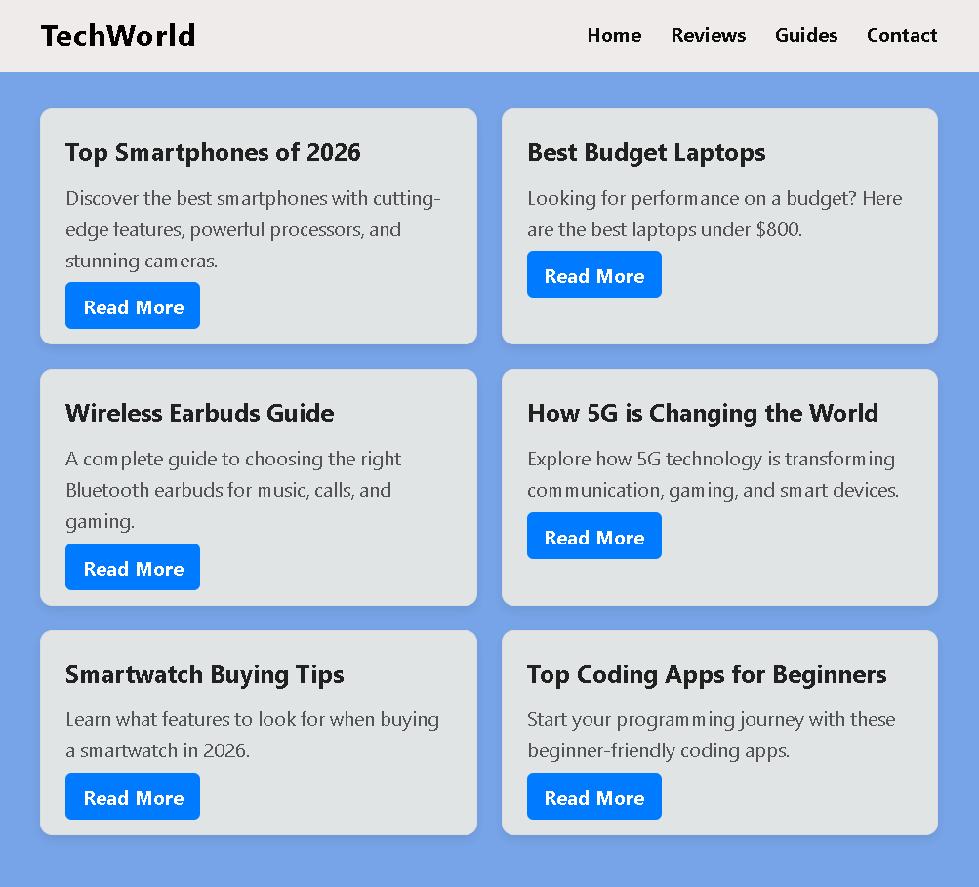

Code Explanation:
The page begins with <!DOCTYPE html>, which declares the document as HTML5.
• The <html> and <head> sections define the language, character encoding, page title, and internal CSS styling.
• A CSS reset using * removes default margins and paddings and sets a common font for all elements.
• The <header> contains the website title “TechWorld” and a navigation menu with links like Home, Reviews, Guides, and Contact.
• The .blog-container uses flexbox to arrange multiple blog cards in a responsive grid layout.
• Each .card represents a blog post with a title, description, and a “Read More” button, styled with padding, border, rounded corners, and hover effects.
• Media queries are used to make the layout responsive: three columns on desktop, two on tablets, and one column on mobile screens.

Problem 5: Responsive Dashboard Layout (Level-2)
Scenario
You are designing a simple admin dashboard layout for a web application.
📌 Requirements
Create a layout with:
- Sidebar navigation
- Main content area
- Info cards inside the main section
Use:
- display properties
- Flexbox or Grid for page structure
Style:
- Sidebar with background color
- Cards with borders, padding, and margins
Apply media queries to:
- Convert sidebar into top navigation on mobile
- Stack cards vertically on small screens

🛠️ Technical Constraints
- HTML + CSS only
- No JavaScript
- No external UI libraries

🎯 Learning Outcome
You will be able to:
- Master page layouts using Flexbox/Grid
- Apply modern responsive web design techniques
- Understand how layout adapts across devices
- Build industry-relevant UI structures

CODE:
<!-- Arshiya_Anjum_HTML&CSS_Day3_Handson_problem_Statement5-->
<!DOCTYPE html>
<html lang="en">
<head>
<meta charset="UTF-8">
<title>Responsive Dashboard</title>

<style>
/* Reset */
* {
box-sizing: border-box;
margin: 0;
padding: 0;
font-family: Arial, sans-serif;
}

body {
background: #f4f6f9;
}

/* Main layout */
.dashboard {
display: flex;
min-height: 100vh;
}

/* Sidebar */
.sidebar {
background: #2c3e50;
color: white;
width: 220px;
padding: 20px;
}

.sidebar h2 {
margin-bottom: 20px;
text-align: center;
}

.sidebar a {
display: block;
color: white;
text-decoration: none;
padding: 10px;
margin: 8px 0;
border-radius: 5px;
}

.sidebar a:hover {
background: #34495e;
}

/* Main content */
.main {
flex: 1;
padding: 20px;
}

.main h1 {
margin-bottom: 20px;
}

/* Card container */
.cards {
display: flex;
gap: 20px;
flex-wrap: wrap;
}

/* Individual cards */
.card {
background: white;
flex: 1 1 calc(33.33% - 20px);
padding: 20px;
border: 1px solid #ddd;
border-radius: 10px;
text-align: center;
}

.card h3 {
margin-bottom: 10px;
}

.card p {
font-size: 20px;
font-weight: bold;
color: #007bff;
}

/* Tablet */
@media (max-width: 900px) {
.card {
flex: 1 1 calc(50% - 20px);
}
}

/* Mobile */
@media (max-width: 600px) {
.dashboard {
flex-direction: column;
}

/* Sidebar becomes top nav */
.sidebar {
width: 100%;
display: flex;
justify-content: space-around;
align-items: center;
padding: 10px;
}

.sidebar h2 {
display: none;
}

.sidebar a {
margin: 0;
padding: 8px;
font-size: 14px;
}

/* Stack cards vertically */
.card {
flex: 1 1 100%;
}
}
</style>
</head>

<body>

<div class="dashboard">

<!-- Sidebar -->
<aside class="sidebar">
<h2>Admin</h2>
<a href="#">Dashboard</a>
<a href="#">Users</a>
<a href="#">Reports</a>
<a href="#">Settings</a>
</aside>

<!-- Main content -->
<main class="main">
<h1>Dashboard Overview</h1>

<div class="cards">
<div class="card">
<h3>Total Users</h3>
<p>1,250</p>
</div>

<div class="card">
<h3>Sales</h3>
<p>$8,430</p>
</div>

<div class="card">
<h3>Orders</h3>
<p>320</p>
</div>

<div class="card">
<h3>New Messages</h3>
<p>45</p>
</div>

<div class="card">
<h3>Active Sessions</h3>
<p>89</p>
</div>
<div class="card">
<h3>Server Load</h3>
<p>65%</p>
</div>
</div>
</main>
</div>
</body>
</html>

OUTPUT:

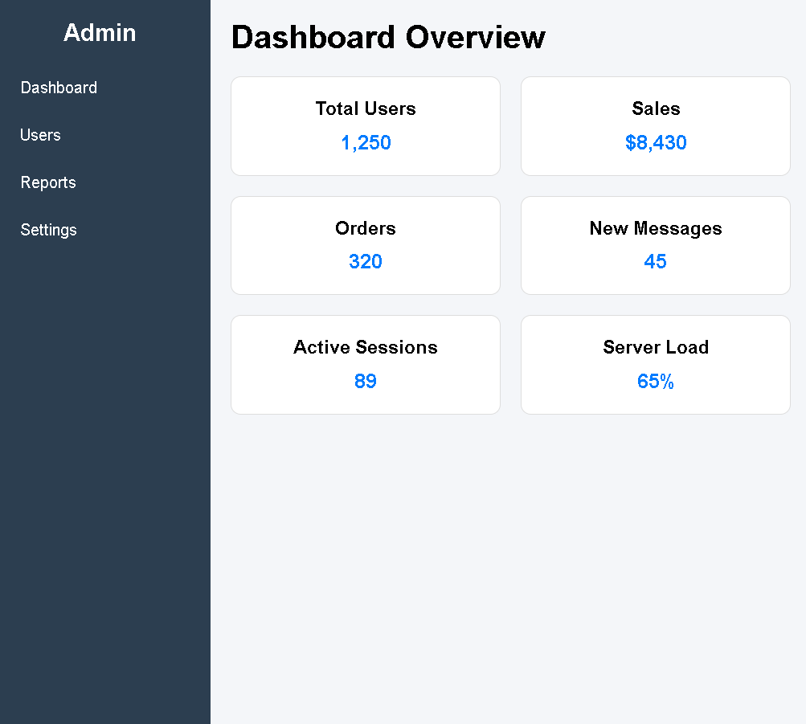

Code Explanation:

The page begins with <!DOCTYPE html>, which declares the document as HTML5.
• The <html> and <head> sections define the language, character encoding, page title, and internal CSS styling.
• A CSS reset using * removes default margins and paddings and applies a common font to all elements.
• The main layout is created using a .dashboard container with flexbox, which holds the sidebar and main content side by side.
• The .sidebar contains navigation links like Dashboard, Users, Reports, and Settings, styled with a dark background and hover effects.
• The .main section displays the dashboard heading and a set of statistic cards arranged using flexbox.
• Each .card shows a title and value, and media queries make the layout responsive: multiple columns on large screens and stacked layout with a top navigation sidebar on mobile devices.

